
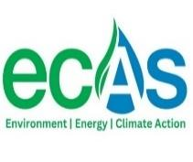

TECHNICAL REPORT DOCUMENTING WRITE-SHOP DISCUSSIONS AND DELIBERATIONS FOR THE DEVELOPMENT OF NAIROBI CITY COUNTY AIR QUALITY REGULATIONS

VENUE: WARIDI (HADASSAH) PARADISE, HOTEL NAIROBI, KENYA
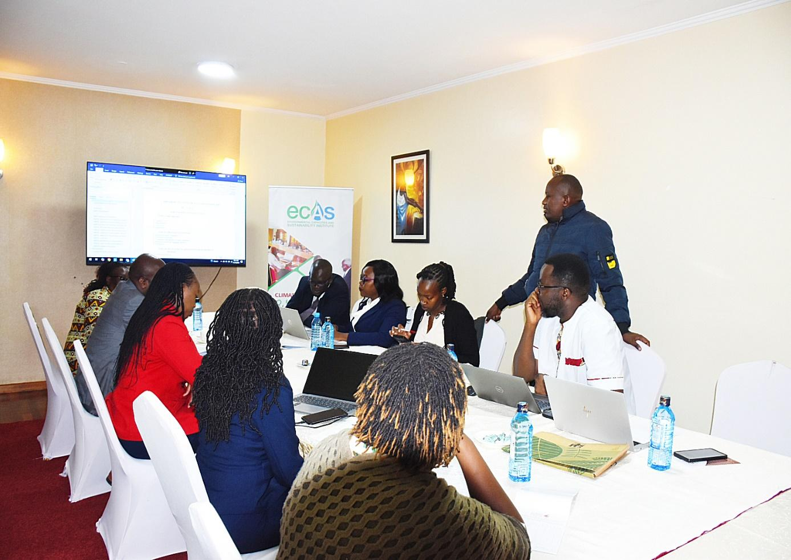
DATE: 13th -19th November, 2024

Report Prepared by
ECAS Institute
P.O. Box 19317- 00100
Beverly Court, Marcus Garvey Lane, Kilimani, Nairobi, Kenya.

TABLE OF CONTENTS

ACKNOWLEDGEMENT 5
CHAPTER ONE: INTRODUCTION 6
1.1 Overview 6
1.2 Project Background 7
1.3 Objectives of the Writeshop 7
1.4 Participant Details 7
CHAPTER TWO: WRITESHOP METHODOLOGY………………………………………9
2.1 Overview 9
2.2 Opening Session 10
2.3 Session One: Definitions, and Review of Air Quality Standards 11
2.4 Session Two: Industrial and Mobile Sources Review 13
2.5 Session 3: Emissions Licensing, Open Burning, and Non-Attainment Areas 15
2.6 Session 4: Monitoring, Occupational Health & Air Quality Management Plans……………….16
2.7 Session five; Air Quality Assessment, monitoring, licensing and Compliance 18
CHAPTER THREE: FINDINGS AND RECOMMENDATIONS………………………20
CHAPTER FOUR: CONCLUSION AND NEXT STEPS 22
APPENDICES 23
Appendix 1: Programme 23
Appendix II: List of participants 24

LIST OF FIGURES
Figure 1: Mr. Maurice Kavai (NCCG Deputy Director of Environment), giving his opening remarks and officially opening the technical write-shop 10

Figure 2: Legal representative from NCCG Attorney’s office giving her inputs during the technical write-shop 12
Figure 3: The drafting team collaboratively working on the Nairobi City County Government air quality regulations during the technical write shop. 14
Figure 4: NCCA lead counsel making his contribution during the technical writeshop 15
Figure 5: Dr. Mwaniki and the NCCA lead counsel in discussion during the technical writeshop 18

ACKNOWLEDGEMENT
The success of the Technical Write-Shop on Nairobi City County Air Quality Regulations Development was made possible through the concerted efforts and invaluable support of numerous stakeholders dedicated to enhancing Nairobi’s air quality.
We extend our sincere gratitude to the Nairobi City County Government (NCCG) and Nairobi County Assembly (NCCA) for their commitment to developing policies that safeguard public health and the environment, and to the National Environment Management Authority (NEMA) for their technical expertise and guidance, which were instrumental in shaping a regulatory framework that is both practical and comprehensive for Nairobi. Their support ensures that these regulations align with both local needs and international standards.
We also deeply appreciate the role of Breathe Cities and the Clean Air Fund, whose dedication to improving global air quality through targeted, city-specific actions has been invaluable. Their financial and technical support enabled us to convene key stakeholders, engage in-depth discussions, and draw on best practices from other global cities. With additional support from C40 Cities and Bloomberg Philanthropies, this initiative has benefitted from international insights that enhance the rigor and effectiveness of the proposed regulations.
Notable contributions were also made by respected industry experts, whose insights greatly enriched the workshop discussions. Prof. Wandiga of the ECAS Institute shared his extensive knowledge on air quality management, adding depth to the regulatory framework’s scientific foundation. Dr. Mwaniki of the World Resources Institute (WRI) provided invaluable perspectives on data-driven approaches and monitoring systems, while Mr. Gisore, a distinguished advocate in Kenya, brought legal insights that helped refine enforcement provisions.
We also thank all other participants, including industry representatives, civil society, and community leaders, whose active engagement fostered a collaborative approach to addressing air quality challenges in Nairobi. Each contribution has helped lay a promising foundation for clean, healthy air in Nairobi City County.

INTRODUCTION

__________________________________________________________

Overview
Air pollution remains a critical public health and environmental challenge worldwide, with profound impacts on biodiversity, climate, and human health. As urbanization and industrialization accelerate, particularly in fast-growing cities, pollution levels have escalated, posing serious risks to respiratory and cardiovascular health, contributing to climate change, and affecting ecosystems. In Nairobi City County, as in many major urban centres, rapid urban growth, increased transportation, and industrial activity have resulted in air quality concerns that threaten both the well-being of residents and the local environment.
To address these challenges, Nairobi City County is undertaking substantial steps to establish a comprehensive regulatory framework that ensures clean, healthy air for all. This technical write-shop represents a pivotal step in these efforts, gathering experts, stakeholders, and policymakers to collaboratively shape a robust set of air quality regulations tailored to Nairobi’s unique needs and conditions. The framework will focus on setting clear emission limits, implementing rigorous monitoring practices, and establishing effective enforcement mechanisms.
A major goal of this initiative is to align Nairobi's local standards with international best practices, ensuring that its regulations are informed by successful models from other cities and meet global benchmarks for air quality management. Through this alignment, Nairobi aims to reduce pollutant levels, safeguard public health, and create a sustainable urban environment that can serve as a model for other cities facing similar challenges. This effort also places Nairobi on the path to contributing meaningfully to international climate commitments by curbing emissions and enhancing resilience to climate impacts. The collaborative spirit of this write-shop underscores Nairobi’s commitment to transformative action for cleaner air and a healthier, more sustainable future.

Project Background
The Breathe Cities initiative, led by a partnership between the Clean Air Fund, C40 Cities, and Bloomberg Philanthropies, is dedicated to helping cities worldwide reduce air pollution and greenhouse gas emissions. This initiative supports urban centres by focusing on data and research, engaging stakeholders and communities, providing technical policy assistance, and sharing best practices. In Kenya, Breathe Cities is working closely with Nairobi City County to develop robust air quality regulations that address the city’s unique pollution challenges and align with national standards.
Through targeted policy development, the project aims to regulate emissions from key sectors, including transportation, waste management, and industry, contributing to cleaner air and a healthier urban environment. The project also includes essential training for enforcement personnel, which will enhance the effective implementation of these new regulations, ensuring that the guidelines are not only established but actively enforced. This collaboration underscores a commitment to sustainable urban development and climate resilience for Nairobi, setting a benchmark for cities across the region.

Objectives of the Writeshop
The workshop aimed to develop a comprehensive set of air quality regulations tailored to Nairobi's unique environmental and public health needs. Key objectives included outlining clear regulations for emission standards, monitoring protocols, and enforcement mechanisms to ensure effective implementation. Additionally, the workshop sought to gather valuable insights, foster collaboration, and build consensus on specific regulatory measures by engaging a diverse group of stakeholders. These efforts were designed to create a robust framework for improving air quality and protecting public health in the city.

Participant Details
The writeshop convened a distinguished assembly of senior officials, environmental specialists, legal professionals, and air quality experts to collaboratively tackle the pressing environmental challenges facing Nairobi City County. Key participants from the Nairobi City County Government included the Deputy Director and Assistant Director of Environment, Climate Change, and Air Quality, and various sector representatives all of whom were pivotal in shaping and overseeing the city’s environmental policies and initiatives. A senior legal representative from the County Attorney’s Office ensured that proposed actions were aligned with legal frameworks, adding a critical layer of compliance to the discussions.
The Nairobi City County Assembly (NCCA) was represented by a highly capable team, including the NCCA Environment Committee Clerk and legal experts, reflecting the legislative commitment to advancing sustainable environmental policies. The write-shop was organized by the ECAS Institute, renowned for its expertise in environmental law and policy. The ECAS team, comprising legal and environmental specialists, facilitated discussions and guided the formulation of actionable recommendations.
Air quality expertise was provided by esteemed professionals such as Dr. George Mwaniki of the World Resources Institute, an organization globally recognized for its work in sustainable development and environmental health. Professor Shem Wandiga of ECAS contributed his extensive experience in environmental science and pollution control advocacy, while, among other participants, Mrs Margaret Kariuki of the Environmental Compliance Institute brought valuable insights from her expertise in air quality management and regulatory compliance.
This diverse and multidisciplinary group of participants ensured a robust exchange of ideas and technical insights. Their collaboration was instrumental in crafting strategies to improve Nairobi’s air quality while addressing broader challenges related to climate change and environmental sustainability. The write-shop laid a strong foundation for actionable, well-informed policies aimed at creating a healthier and more sustainable future for Nairobi.

WRITESHOP METHODOLOGY

__________________________________________________________

Overview
The writeshop spanned five days, from November 13 to 19, 2024, excluding weekends. The review process was methodically structured into five sessions, with each session corresponding to a specific day and focusing on distinct aspects of the draft air quality regulations. This structured approach ensured a comprehensive and systematic review process, fostering in-depth discussions and actionable outcomes.
- Session One: This session centered on preliminary feedback from individual team members based on their personalized reviews of the shared draft. It included the revision of key terms used in the document and an initial review of sections related to emission standards.
- Session Two: The second session delved deeper into refining emission standards and addressing emissions from both industrial and mobile sources, ensuring clarity and practical applicability.
- Session Three: The third session focused on emissions management, particularly addressing open burning and the management of non-attainment areas to align with broader environmental objectives.
- Session Four: This session examined monitoring protocols, occupational health considerations, and the development of air quality management plans to create a cohesive framework for implementation and enforcement.
- Session Five: The final session was dedicated to reviewing air quality assessment, monitoring, licensing, and compliance mechanisms, ensuring that the regulations provided clear and actionable guidance for enforcement and reporting.

Opening Session
The session commenced promptly at 9:15 a.m., led by Deputy Director Maurice Kavai from the Nairobi City County Government. As the facilitator, he set the tone for the day by presenting the air quality draft regulations. In his opening remarks, Kavai reaffirmed Nairobi City County Government’s unwavering commitment to advancing air quality management and environmental protection. He emphasized the importance of collaborative efforts in shaping robust regulations that would address the pressing air quality challenges facing the city.


Figure 1: Mr. Maurice Kavai (NCCG Deputy Director of Environment), giving his opening remarks and officially opening the technical writeshop
During his presentation, Kavai highlighted key priority areas outlined in the draft, including Emission Standards and Pollutant-Specific Limits, which aim to establish clear thresholds for pollutants to safeguard public health and the environment. He also stressed the need for well-defined Compliance and Reporting Requirements, ensuring accountability among stakeholders and industries. Further, the draft proposed comprehensive frameworks for Monitoring, Enforcement, and Penalty Structures to ensure adherence to the regulations. Equally important, Kavai underscored the necessity of Capacity Building and Public Engagement, focusing on equipping stakeholders with the knowledge and tools required to implement the regulations while fostering public awareness and participation.
Following the presentation, the participants engaged in an in-depth discussion to determine the best approach to reviewing and refining the draft regulations. After thorough deliberation, the team unanimously agreed to adopt a systematic, joint approach of reviewing the document page by page. This strategy was deemed the most effective for ensuring that each provision was thoroughly analyzed, gaps identified, and improvements proposed collaboratively. The consensus underscored the commitment of all stakeholders to developing a robust, inclusive, and actionable air quality regulatory framework for Nairobi City County.

Session One: Preliminary Feedback, Revision of Definitions, and Review of Air Quality Standards
The session commenced with a collaborative review of the draft regulations, focusing on key feedback, refining definitions, and addressing air quality standards and emission limits. Participants began by evaluating the title of the draft regulations, unanimously agreeing to retain the current title to ensure alignment with the relevant Act. It was further proposed and accepted that the term ambient be added to emphasize the focus on ambient air quality management.

Preliminary Feedback
Feedback from participants’ independent reviews identified several critical areas for revision. Part III was renamed from Motor Vehicle Sources to Mobile Sources to encompass additional contributors such as construction machinery and locomotives. Part IV was revised to merge Industrial Facilities into Stationary Sources to enhance clarity and address unique regulatory requirements. In Part VII, inter-county emissions were updated to Transboundary emissions to reflect broader cross-border pollution concerns. Additionally, specific revisions were proposed for Section 11 to streamline its content, although detailed changes were not specified.

Revisions to Definitions
The definitions section underwent a critical review to ensure clarity, consistency, and relevance. Key revisions included simplifying the definition of Aerosols by removing words after "particles" and updating Electrostatic Particles to include "charged particles." The definition of Exposure Limits was expanded to incorporate "maximum allowable exposure concentrations," while Equipment Start-Up was simplified by removing the term "normal." Terms such as Competent, Existing Source, and Measurement were deleted due to their lack of usage in the draft. Additionally, the Directorate was replaced with the Department to align with current organizational structures, and the Limit Level was revised to conform with existing national standards.

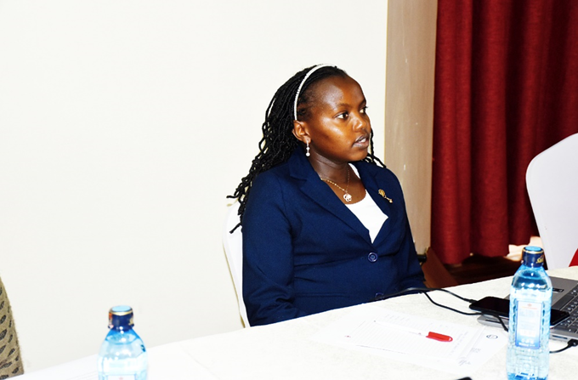

Figure 2: Legal representative from NCCG Attorney’s office giving her inputs during the technical writeshop

Review of Air Quality Standards and Emission Limits
Discussions progressed to refining air quality standards and emission limits, with a focus on ensuring alignment with regulatory frameworks and practical implementation. Section 7 was revised for full compliance with Schedule 1, establishing clear connections between outlined standards and air quality management regulations. Updates to Section 8 (Licensing and Permitting) included aligning Sub-regulation 1, parts (b) and (c), with pollution thresholds specific to environmental zones, thereby enabling tailored pollution limits comparable with National set standards. Schedule 3 was earmarked for reworking to develop customized standards for Nairobi, with Sub-regulation 4 amended to mandate collaboration with the Kenya Bureau of Standards (KEBS) to align standards to national benchmarks. Revisions to Section 9 (Exemptions) addressed Sub-regulation (e) and Schedule 7 by removing references to savanna burning in part (d) for improved relevance.
Additional revisions included Section 14 (general prohibitions) , where Sub-regulation (a) was deleted for being overly punitive, Sub-regulation (c) was expanded to prohibit any form of open burning, and Sub-regulation (d) was clarified to specify exclude water-based paints from prohibitions. In Section 15(stationary sources), Sub-regulation 1 was revised to align with emission limits set in Section 8, Sub-regulation 3(b) was refined for specificity, and Sub-regulation 5 was updated to emphasize the necessity of proper authorization by including the phrase without license or permit.

Revisions to Schedules
Schedules 2, and 3 were identified and referred for further updates to reflect the latest national and global standards. The team emphasized the importance of correctly pairing schedules with their corresponding sections in the draft to maintain coherence and alignment throughout the document.

Session Two: Industrial and Mobile Sources Review
The team reviewed part III (stationary) and part IV (industrial) sources focusing on refining and consolidating sections to enhance clarity and practical implementation. Section 30(industrial sources) was deleted, with its relevant content merged into Section 15so as to be part of Stationary Sources. Additionally, a new subsection (3) was introduced, requiring industrial facilities with emissions exceeding limit levels to seek authorization before setup. Section 30, Part (a), was revised to mandate the immediate reporting of air pollution events. Schedule 11 was identified for comprehensive updates to align with the latest standards, and Section 31 was enhanced with a new subsection emphasizing the prompt reporting of potential threats to air quality.

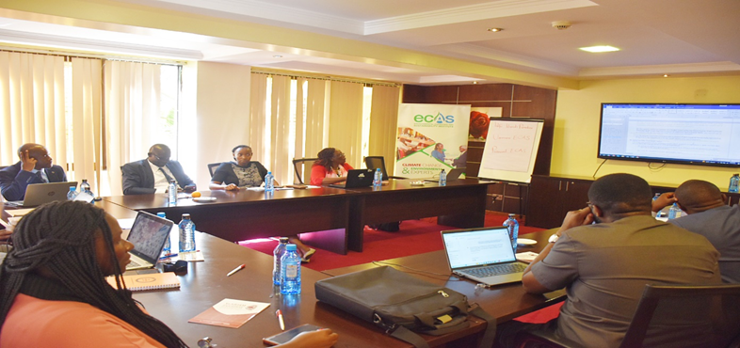
Figure 3: The drafting team collaboratively worked on the Nairobi City County Government air quality regulations during the technical write shop.
The review of sections addressing mobile sources and fugitive emissions introduced key revisions to ensure comprehensive coverage and alignment with established standards. Section 16 was updated by replacing the term motor with mobile, broadening its scope to encompass all mobile pollution sources. Emission limits were aligned with the KS EAS1047:2022 standard to maintain consistency with established benchmarks. Section 17, Part 2, included exemptions for idling emissions and added pollution control measures for construction equipment and machinery. Sections 18 and 19 were revised to incorporate relevant county sectors, authorities, and institutions, enhancing coordination and accountability for monitoring and enforcement. In Section 20, the term seventh schedule was replaced with the tenth schedule for accurate referencing. Section 21 emphasized the implementation of precautionary measures for fugitive emissions while removing references to NEMA to focus on county-level responsibilities.
Section 22, which outlined the Fugitive Emissions Control Plan, underwent significant revision. Subsections 4, 5, and 6 were retained for their relevance, while Part 9, referencing a nonexistent schedule, and Part 11 were deleted. Regarding other emission sources, Sections 23 and 24 were removed due to redundancy, and Section 25 was deleted with industrial facilities redefined to include incinerators. Finally, Section 26 was eliminated as its content aligned more closely with climate change issues than air quality management. These changes aimed to streamline the regulations and enhance their applicability to Nairobi’s unique context.

Session 3: Review of Regulations on Emissions Licensing, Open Burning, and Non-Attainment Areas
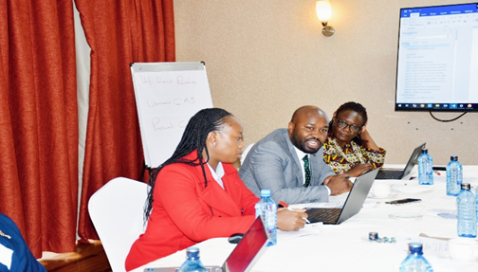
Section 34, addressing emission licenses in non-attainment areas, was revised to empower the County Executive Committee (CEC) to recall licenses for all emission sources within such areas, enhancing regulatory enforcement in regions failing to meet air quality standards. Part 3 of the section was also updated to align with this new provision. Section 35 was removed, as its content on PM2.5 standards was already addressed elsewhere in the regulations, thereby avoiding redundancy.
Figure 4: NCCA lead counsel making his contribution during the technical writeshop

Section 36, concerning open burning, was expanded to include comprehensive guidelines. Sub-regulation 2 introduced mandatory notifications for bonfires to ensure proper oversight. Sub-regulation 3, parts (a) and (b), were removed to eliminate irrelevant content, while Part 4 was revised to detail the approval process for open burning. These revisions introduced timelines for application processing, criteria for approval or rejection, and mechanisms for appeals to promote transparency and fairness.
Section 37 explicitly prohibited burning in non-attainment areas through a new sub-regulation, reinforcing air quality safeguards in regions with poor air quality. References to NEMA were removed to reflect the county's localized enforcement role. Additionally, Sub-regulation 1, parts (d) and (f), were deleted as they were inconsistent with the regulations' objectives.
These updates collectively strengthen the regulatory framework, ensuring a clearer, more enforceable approach to emissions management and air quality preservation.

Session 4: Refinement of Regulations on Monitoring, Occupational Health, and Air Quality Management Plans
The fourth session focused on revising sections related to occupational health, air quality monitoring, and management plans to ensure alignment with relevant jurisdictions, enhance accountability, and streamline implementation. Sections 38, 39, and 40 were reserved for occupational health matters under the Occupational Safety and Health Administration (OSHA). These sections were deemed unnecessary in the draft regulations as they fall under national jurisdiction.
Part VII: Transboundary Emissions’ major sections were deleted since managing transboundary emissions is the responsibility of national agencies. However, sub-regulations 1 and 2 were retained to address the limited roles counties play in managing air quality at the border level. Section 41, sub-regulation 3, along with other redundant clauses, was removed.
Part VIII: Monitoring and Management Plans saw significant updates: Section 43: Sub-regulation 1 was revised to remove references to NEMA and broaden the scope to include all pollutants. Sub-regulations 2 and 4 were deleted for redundancy or irrelevance to county responsibilities. Section 44: The air quality plan's contents were revised to expand the scope beyond NEMA's remit. Additional sub-regulations were introduced to improve the comprehensiveness of air quality management plans. Section 45: Revised to mandate submission of air quality plans to the Nairobi City County Assembly for resource allocation, ensuring funding and oversight.
Section 46: The Monitoring Framework underwent extensive revisions, introducing a robust three-tier monitoring system:
- Designated Monitoring Stations: Each zone, defined by six emission criteria, must have a designated station.
- Stationary Sources: Listed sources in Schedule 2 must conduct outlet emission monitoring.
- Non-Attainment Zones:
  - The department must develop air quality management plans for zones failing to meet standards.
  - The County Executive Committee (CEC) must declare such zones as non-attainment areas.
  - Facilities in these zones are required to develop mitigation plans and submit quarterly emission reports, subject to random toxic emissions checks by the department.
Schedule 2 was updated to categorize pollutants into criteria and toxic categories. Sub-regulations 2 and 3 were merged, while sub-regulation 3 was deleted for redundancy.
- Section 47: Deleted as delayed reporting provisions were unsuitable for effective air quality management.
- Section 48: Retained without changes due to its relevance.
- Section 49: Sub-regulation 3 was deleted as unnecessary.
These revisions aim to create a more effective framework for monitoring, enforcing, and planning air quality measures, emphasizing localized enforcement and immediate action in non-attainment areas.

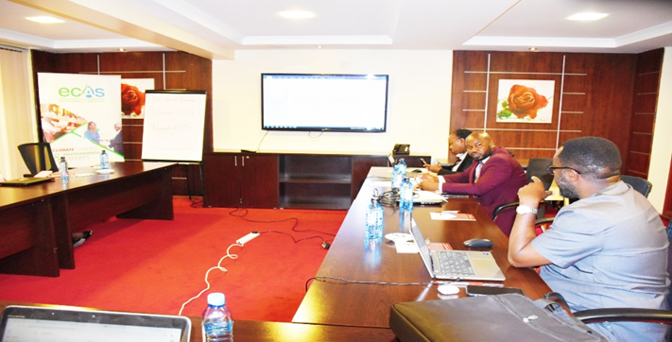
Session five; Air Quality Assessment, monitoring, licensing and Compliance
Figure 5: Dr. Mwaniki and the NCCA lead counsel in discussion during the technical writeshop
The sixth session focused on refining sections related to air quality assessment, monitoring, licensing, and compliance to ensure coherence, eliminate redundancies, and align the regulations with existing frameworks. Sections 50, 51, 52, 54, 55, and 62 were deleted or merged with other sections, as their provisions were already addressed under monitoring (Section 46) or other relevant sections. Section 53 was retained as is, while Section 56 was streamlined to retain only sub-regulation 4, and Section 57 was deleted entirely for irrelevance. In Section 58, the schedule reference was revised from seven to ten, sub-regulation (b) was deleted, and a clause was added to address submissions of in-use air quality technology, while other sub-regulations were removed. Section 59 was retained, highlighting expertise development in Sweden, and Section 60 was revised to focus on the State of the Nairobi Air Quality, with provisions for reporting to the County Assembly and aligning references to the First Schedule. Section 61 was simplified by deleting nonsensical or redundant sub-regulations. Revisions to Part X on licensing included renaming Section 63 to focus on stationary sources, removing references to non-attainment areas, and adding provisions for provisional air quality licenses for new applicants. Sections 64, 65, and 66 were revised to align with appropriate schedules and compliance plans, while Section 70 was deleted for being overly punitive. Lastly, Section 73 was updated to ensure alignment with relevant sections of the Act. These refinements aim to enhance regulatory clarity, promote effective monitoring and enforcement, and ensure practical implementation.

FINDINGS AND RECOMMENDATIONS

__________________________________________________________
The following findings and recommendations were established during the review and revision process:
- Defined Terms and Schedules
Only defined terms that are actively used in the draft should be retained, along with schedules that form an integral part of the regulations.
Schedules should undergo further review to align with the latest national and global standards, ensuring relevance and compliance.
- Title Revision
It was recommended that the title be revised to include the term ambient, reflecting the regulations' focus on ambient air quality control.
- Occupational Air Quality Regulations
Issues related to occupational air quality should remain under the Occupational Safety and Health Administration (OSHA) to prevent overlapping mandates.
- Transboundary Air Quality Management
Transboundary air quality issues should be handled by the national agency, with disputes resolved through existing dispute resolution mechanisms.
- Penalties
Penalties were revised to maintain deterrence without being overly punitive, thereby balancing regulatory enforcement with the need to encourage investment and business operations.
- Implementation Guidelines
The Nairobi City County Government (NCCG) should prioritize developing clear guidelines for implementing the proposed regulations.
- Mobile Sources
The term mobile sources was adopted to replace motor vehicle sources, broadening the scope to include all mobile sources of pollutants such as construction equipment and locomotives.
- Exposure Limits
The definition of exposure limit was expanded to include maximum allowable concentrations, enhancing clarity and regulatory precision.
- Prohibition on Open Burning
The regulations emphasize a general prohibition on any form of unlicensed open burning as a fundamental measure to improve air quality.
- Standards Alignment
Air quality standards set in the draft should align with relevant KEBS standards and other recognized national and global benchmarks.
- Non-Attainment Areas
The NCCG should identify and declare non-attainment areas to support the targeted implementation of air quality regulations.
- Air Quality Management Plans
Air quality management plans should be developed for both non-attainment and other areas, serving as tools for effective regulation and enforcement.
- Reporting and Oversight
The NCCG should prioritize periodic sharing of air quality plans and compliance reports with the Nairobi City County Assembly to ensure transparency, resource allocation, and legislative oversight.

CONCLUSION AND NEXT STEPS
The write-shop resulted in the production of a finalized draft of the Nairobi City County Air Quality Regulations (attached). The next steps include:
- Validation: The finalized draft will be shared with stakeholders for validation, additional input, and dissemination of information.
- Stakeholder Engagement: Feedback from stakeholders will be incorporated into the final version to ensure comprehensiveness and practicality.
- Implementation Planning: Guidelines and frameworks for implementing the regulations will be developed to facilitate smooth adoption and enforcement.

APPENDICES

Appendix 1: Programme

Day | Focus Area | Activities | Expected Outputs
Day 1 | Opening and Introduction | - Registration and welcome session.  - Keynote speeches by NCCG representatives and partners.  - Overview of the draft regulations and objectives. | Shared understanding of goals and participant roles.
Day 2 | Emission Standards and Definitions | - Review of key terms and definitions in the regulations.  - Group work on refining emission standards.  - Feedback consolidation on clarity and scope. | Updated draft with agreed-upon definitions and standards.
Day 3 | Sectoral Challenges and Solutions | - Breakout sessions by sector (transport, industry, waste management).  - Discussion of key sectoral challenges.  - Collaborative identification of mitigation strategies. | Actionable sector-specific recommendations.
Day 4 | Compliance, Monitoring, and Enforcement Mechanisms | - Review of compliance structures.  - Development of monitoring and reporting frameworks.  - Assigning enforcement roles and responsibilities. | Practical compliance and enforcement strategies.
Day 5 | Finalization and Next Steps | - Consolidation of all feedback.  - Refinement of regulations based on workshop inputs.  - Vote of thanks and next steps outlined. | Finalized draft and stakeholder commitments to implementation.

Appendix II: List of participants
 | LIST OF PARTICIPANTS
No. | Name of Participant | Organization
1 | Audrey Kisuya | Communications Officer, ECAS Institute
2 | Samuel Ochieng | Program Officer, ECAS Institute
3 | Eunice Otieno | Project Officer, ECAS Institute
4 | Dr. George Mwaniki | Head of Air Quality, World Resource Institute- Africa
5 | Joy Mathenge | Legal Officer, Nairobi City County Government
6 | Munase Mukhombwa | Legal Officer, Nairobi County Assembly
7 | Maurice Kavai | Dep. Director Environment, Nairobi City County Government
8 | Mercy Kiunga | Clerk, Nairobi City County Assembly
9 | Kevin Waswe | Nairobi City County Assembly
10 | Prof. Shem Wandiga | Vc. Jaramogi Oginga Odinga Univesity
11 | Jolinda Wanju | Nairobi City County Assembly
12 | Helen Mutiu | Nairobi City County Assembly
13 | Grace Ojiayo | Assistant Deputy Director Environment, Nairobi City County Government
14 | Margaret Kariuki | Environmental Compliance Institute
15 | Jacob Olonde | CEO, ECAS Institute
16 | Gibson Gisore | Advocate, ECAS Institute
17 | Diana Pambo | NCCG
18 | Crispus Michira | NCCG
19 | Derrick Sisulu | ECAS
20 | Anna Otieno | NCCG
21 | Christine Kivuva | Assistant Director, NCCG
22 | Noah Ngeno | NCCG
23 | Calvin Owino | NCCG
24 | Lawrence Mwangi | NCCG
25 | Nancy Nasepeya | NCCG

